**Bipartite Graphs:**

These are graphs that only have edges leaving nodes and connecting to other nodes of a different type. For example, if the nodes are fans and the other nodes are teams, it’s unlikely that fans are fans of other fans, they will only be fans of the teams. There is no connection directly between these fans.

**Bipartite graph:** a graphs whose nodes can be split into two sets L and R and every edge connects a node in L with a node in R.

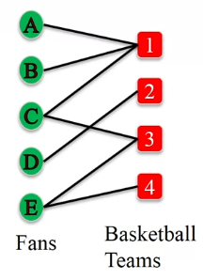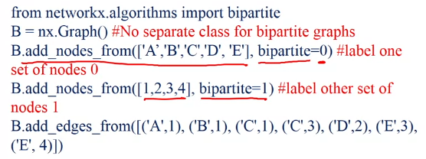

**Question:** Which of these is bipartite?

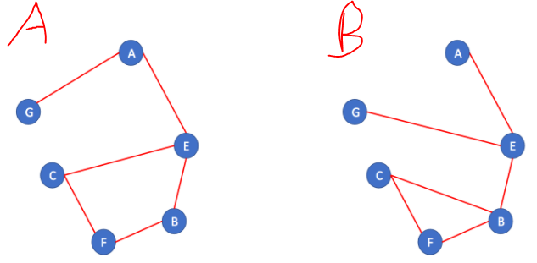

Only A, the sets are {A,B,C} and {G,E,F}.

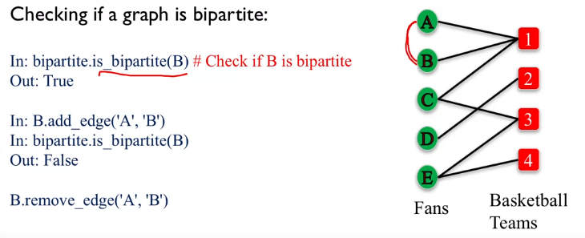

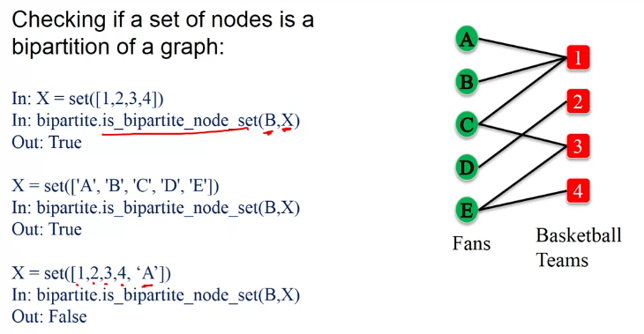

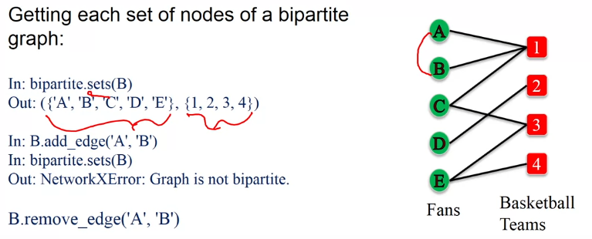

From Bipartite graphs you can make another graph that looks at the connect between nodes of the same set. For example, we might be interested in the connectivity of who supports which team and how they are connect to each other. This type of information could be useful for marketing as they could apply strategic marketing to the groups that come out of this analysis. This is called an **L-Bipartite graph projection**.

**L-Bipartite graph projection** **definition**: Network of nodes in a group L, where a pair of nodes is connected if they have a common neighbour in R in the bipartite graph.

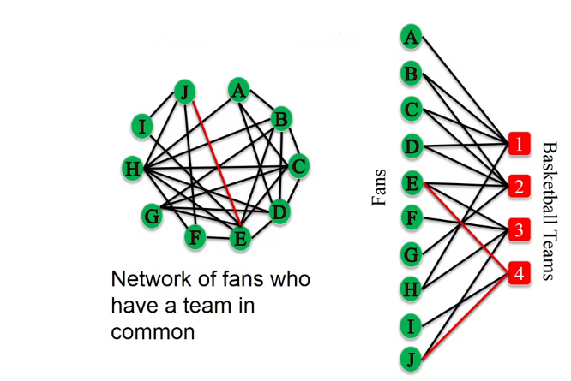

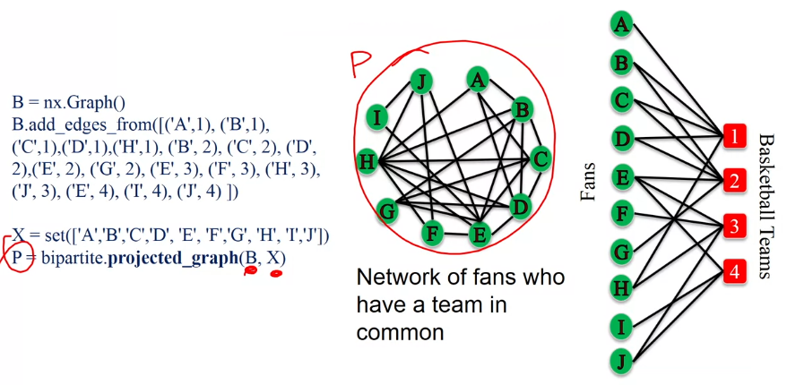

In the above code, B is the Bipartite graph and P is this L-Bipartite Graph Projection.

For the figure below. This time we’re looking at the set of teams and what fans they have in common, an edge represents if they have common fans. We can see from the L graph that for some edges there are more connecting fans than others, for this reason it would be sensible to have a weighted connection of edges.

